** 8+ years of Website Development Experience

** Fluent English

** Love to Design and Develop cool Websites I am obsessive about: ---------------------------

** Communications

** Keeping you well informed during the project.

** CODE - Structures, Readable, Commented and Easily Supported

**DESIGN - Pixel-Perfect

** PERFORMANCE - Should work/load fast, otherwise it does not make any sense. My Experience: -------------------

** Design - Web & Mobile UI/UX

** Front End Development - HTML5, CSS3, Bootstrap & AngularJS

** Web Development - PHP, MYSQL, WordPress & Codeigniter

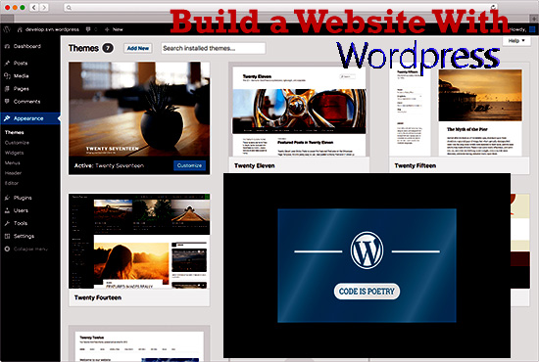

# Title : I will build responsive wordpress ecommerce website for you

**Responsive WordPress Website Design Or Create WordPress Website / Blog**

If you are looking for a Web designer who will build your website with a flexible page builder and you can update the website in the future easily,

**YES!** You are the right place as I will use drag and droppage builder to build your **WordPress web pages**.

I specialize in designing and developing high end, user-oriented, robust and scalable web page design for more than 6 years

**Look no further.** Because I will help you in doing that.

**How?**

* By creating a 100% responsive WordPress website design that your visitors will love.
* By adding Animations, icons and HD Images to make your site look way better than others.
* Also, I will use premium plugins to maximize traffic and shareability

**Here are the services that I offer in this gig**

* Full Website Creation
* WP Installation & Setup
* Bug Fixes
* Customization
* Landing Page
* Backup, Cloning & Migration
* Performance & SEO.

With my skills, I can work on your;

* Co-operate/Business
* Coming Soon pages
* CV or Portfolio sites
* SEO Friendly Blogs
* Real estate business
* Photography
* Political/ Religious OR
* Startup Website **AND MANY MORE**

Professionally, I create **WordPress website design** of any type; giving you nothing less than 100% satisfaction, guaranteed. In addition to that, I am going to ensure your website is completely responsive.

**Please inbox me for quotation and brainstorming your idea via message.**

* Integrating Plugins
  + Adsense
  + Akismet
  + All in One SEO Pack
  + Amazon
  + Aweber
  + Clickbank
  + Contact Form 7
  + Facebook
  + Getresponse
  + Gravity Forms
  + Instagram
  + LinkedIn
  + Mailchimp
  + OpenCart
  + Paypal
  + Twitter
  + Vimeo
  + W3 Total Cache
  + WooCommerce
  + WordPress SEO by Yoast
  + Youtube

Basic : 75

Standard : 150

Gold : 250

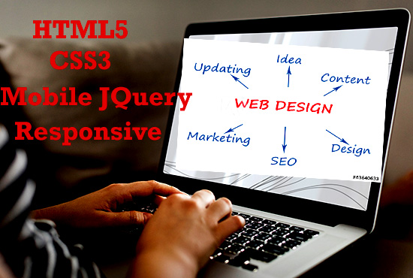

# Title : I will design a professional clickable

# responsive html

## About This Gig

Are you in need of an email signature for your brand?

I am offering to EMAIL SIGNATURE design service.  
  
**What is included?**  
✔Stylish signature like as electronic signature.  
✔Direct communication with mine.  
✔Final logo supplied via email.

# Why Choose me:  Responsive html Email signature Super Fast Delivery life Time Secure Hosting For Images Animated  Email signature Custom Design  according to your demand 100 plus Designs concepts

# == What you will get ==   1. Modern, Unique & Eye catchy email template or newsletter.   2. E-commerce base layout.   3. Editable email template.    4. Spamming free email template.   5. All email client supported template

# ----------ORDER NOW---------- ✽✽ To know more details about how it works, Please Read the FAQ Details before placing the order ✽✽ If you have any Asking Please feel free to Contact me I'm open to Answer your any question, Thank you for Viewing my gig I will be waiting to hear from you.

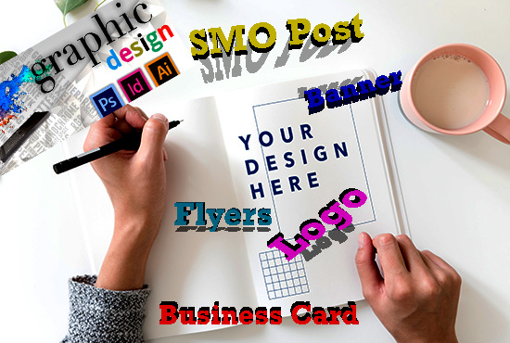

# Title : I will design trendy Photoshop and illustrate graphic.

## About This Gig

In this T-shirt illustration gig, I will draw your ideas in my hand drawn illustration style.  
  
**DIGITAL ILLUSTRATIONS**  
  
I will draw the illustration digitally using a Wacom drawing tablet in  Adobe Photoshop or Adobe Illustrator. I will send you a high resolution file in 300/600 dpi PNG (transparent background) or JPEG as final file, and PSD or AI file as source files.

**Contact me first** to work out the cost of your project and let's work!

**Advanced Portrait Retouching/Beautifying:**

**A few of my services include (but are not limited to):**

* **Logo Designing**(custom, business ,organisations, sports team etc)
* **Branding and Stationery design**
* **Brochure**
* **Posters**
* **Post cards, Greeting Cards etc**
* **Invitation Card**(Wedding, Party etc)
* **Social Media Covers & Headers** (Facebook, YouTube, Google Plus Twitter etc)
* **Face, skin & body:**creating realistic perfect looking skin, removing skin/lip wrinkles, blemishes, eye bags, improve skin, whiten teeth, body slimming, reduce fat on body parts etc...
* **Product Photos:** for Amazon, eBay, Social Media...
* Face swaps
* Add realistic Effects
* Place you anywhere
* Product Photo Retouching
* Adjust contrast/Light
* Enhance colors
* Infographics
* Photo Manipulation

**My service:**

* Fast Delivery and Quick Revision
* JPG, PNG, AI or EPS Vector file
* Free mockup
* 100% Satisfaction Guaranteed
* Some colours
* Easy to communicate
* I prefer the details
* After completing the order, I will send the PNG design and other files.
* You can send me a Custom Offer for various Prices.
* High Resolution any size

# Need anything else?  I work fast, I deliver great quality and I really care about getting the result right.